Writing and Performing
mathematics as metaphor.

Andrew and Jennifer Granville, and Michael Spencer

In 2009 we (the Granville siblings) completed the screenplay
Mathematical Sciences Investigation (MSI)
“The anatomy of integers and permutations”
based on analogies between the mathematical structure of integers and of permutations. This was then performed as a ``staged reading’’, with professional actors, at the Institute for Advanced Study in Princeton, and subsequently at MSRI in Berkeley in 2011, as well as at the Canadian Mathematical Society annual meeting in Montreal in 2012.

The screenplay is an attempt to describe some mathematical research, as well as to illustrate the process of researching in mathematics, in the context of a narrative told in a screenplay. The screenplay encompasses details usually considered far too technical for expository writing, by explaining them through metaphor. Our objective is to reach a wider audience than is usual for mathematical exposition.

We invited a noted experimental stage designer, Michael Spencer, to visually enhance these metaphors by helping us to stage the reading of the screenplay in an evocative manner. We also collaborated with the musician, Robert Schneider, to write a mathematically based score for one particular scene. The screenplay is currently in development as a graphic novel, being drawn by the artist Robert Lewis.

In this article we attempt to outline the challenges and issues, creatively and mathematically, that emerged through the unusual collaboration during the development of this project.

1. Vulgarizing expository writing. By Andrew Granville

Mathematics involves a rich language, invoking precise definitions that deter most people who are not already well versed in its subtleties. There are many types of ``popularizations'' of mathematics, but fundamentally they are all subject to the same dilemma: Writing at too high a level discourages readership, while writing at too low a level does not do justice to the material. So, can one disseminate high-level mathematics to a wider audience?

Generally books and articles that aim at a very wide audience proceed by what might be called ``mathematics tourism''. There are the words of mathematics and the statements of the famous results and conjectures, perhaps even a vague hint as to what different subjects are about, but the mathematics itself is never explored in any depth. One simply visits the facades of mathematics and accepts what is there at face value.

Books that aim to discuss an important topic (for instance, when there has been a recent breakthrough) or biographies, usually include brief attempts to define a few of the key concepts moderately rigorously, and then perhaps some clever, real world analogies to allow the author to describe the real point of the mathematical questions, but there is never any sense of the flavour of the proofs (which is what lies at the heart of the work of a mathematician), or the process that the mathematician goes through to achieve their success. In films and TV, writers sometimes include mathematicians, largely because of their (perceived) eccentric personalities, either as a supporting character (like Jeff Goldblum in Jurassic Park) or as the focus of the movie (as in Good Will Hunting or Proof); but in these films there is little genuine mathematics, just some obscure words and phrases added to make the script sound authentic. Some recent TV series, like CSI and Numb3rs, have attempted to use a little more mathematics (and other sciences), but typically rather basic notions as can best be worked in to the TV crime to hand, and their writers are not looking to exploit deeper concepts that might actually be used in the real world (after all, how would you explain those concepts, without far too many details, to the projected audience?).

Having written quite a few well-received ``popular'' articles, which did not actually reach out to anyone who was not already highly committed to the study of mathematics, I have been interested in trying to reach a genuinely wider audience. When my latest idea for an expository article took shape, I wondered whether it could be presented in a non-traditional way to attract a more diverse audience. The mathematics I was interested in explaining involved the underlying composition of two central mathematical objects, integers and permutations, and the surprising revelation that in many ways their structure seems very similar; so similar, in fact, that they are almost identical. This reminded me of an episode of the TV series, CSI: Crime Scene Investigation in which two different-looking people proved to be twins. Autopsies yielded the crucial evidence … Why not construct a similar revelation from autopsies of integers and permutations? Here is a different idea: reveal the actual mathematics involved by metaphor. Try to write a crime story, involving people, but discuss the clues as mathematics, while at the same time maintain a story that can be enjoyed by non-mathematicians.

This way of presenting mathematics had surely occurred to others, and yet there have been few attempts to do something like this. Most attempts that I could find neither make entertaining reading as a story, nor are they particularly interesting mathematically. One can quickly identity issues that make this kind of writing difficult. For example, if the whole story is to work by metaphor then each of those metaphors must be powerful enough to truly evoke both some interesting mathematical idea, and some important aspect of the storyline.

As a serious mathematician, one does not like to introduce new terminology, especially words that invoke imprecise analogies but, as an expositor of difficult mathematics to an audience with a limited background, it is hard to proceed without doing so. Thus, in “MSI: The Anatomy of Integers and Permutations’, we begin by looking at the ``anatomies'' of various mathematical objects, not too bad a nomenclature, and then move on to ``the component parts'' of the anatomies, which are ``like the DNA of organisms'', in referring to the prime factor decomposition of integers, and the cycle decomposition of permutations. The mathematical story emerges when we study the distribution of the prime factors of ``typical'' integers, and the distribution of the cycle lengths of cycles in a ``typical'' permutation. It turns out, rather surprisingly, that many of the different distribution functions that one might consider are the same. So integers and permutations ``have the same DNA'' and are therefore ``twins''. Now we are really stretching the analogies. But how else can one possibly describe the distribution functions to the lay reader? Some of these are very complicated, even for highly trained mathematicians. At the very least we can describe what feature of the distributions we are considering, and whether the distributions found are standard or surprising.

But how can one describe the working process of a pure mathematics researcher? That is, reading deep papers and modifying the existing theory, so as to develop an appropriate, perhaps new, perspective. How can one make this sufficiently dramatic for a screenplay? Our answer, in MSI, was to proceed as if in a TV crime lab, with mathematicians becoming investigators using ``standard tests'' and recognizing the distribution functions through data analysis. Of course, this is rarely what a real mathematician actually does. One of the better analogies comes in comparing the data from integers and permutations -- a ``typical'' integer n has about loglog n prime factors, while a ``typical'' permutation on N letters has about log N disjoint cycles. So to compare the distribution functions we really do need to ``calibrate'' by replacing N with log n, something that is easy to explain in a wider context.

The writing of over a hundred research articles and more than twenty expository articles, in no way prepared me to develop an article blending mathematics and fiction. The few such efforts that I have read seem very forced, and my first attempts to do so were no different. I could formulate a story, even a plot, but writing dialogue is a lot harder than I'd thought (after all, it is easy enough to criticize the plots and scripts we are barraged with on TV, so why is it not easy to do much better?). On the other hand my sister had been an actress for many years, and had increasingly been turning her hand to her first love, writing, over the last decade. Now that she was writing ambitious screenplays (as well as poetry), why couldn't we write my plot up as a screenplay rather than as a short story? It only took a little persuading for her to give it a go.

We set out to create a fantasy world that would slowly reveal the various relevant mathematical properties of integers and permutations (and to compare them), just as evidence is slowly revealed in the CSI TV dramas. The main issue in our nascent collaboration revolved around the question of whether one can uphold the mathematician's expectation of rigour whilst, at the same time, creating an (allegorical) storyline that might hold the viewer’s attention? Other than Edwin Abbott's 1888 Flatland, which attempted to explain dimension by metaphor (and is also a clever social satire of its time), there have been, to my knowledge, no attempts to do this, and we soon could identify several reasons why these genres, mathematical writing and creative writing, have rarely been mixed together. After all, they have their own cultures and these would appear to pull one in opposing directions.

I wanted to truly explain the mathematics, but how can one create a story that is not just window dressing for the detailed mathematics? A story that actually holds the audience's interest? My sister and I quickly agreed that we would create characters based on major figures of mathematical history, using their personal histories (suitably modernized) as ``backstories’’ for the characters.
Fortunately, mathematical history has no shortage of interesting characters with quirky and compelling stories – think of Karl Friedrich Gauss, Sophie Germain, John von Neumann, Alexander Groethendieck, Serge Lang, even Count Nicolas Bourbaki . Their life stories provided us with a great starting point to create our own characters, with purely fictional personalities, to serve our drama.

To make this work as drama, we needed a story. We needed good guys and bad guys. We decided to fit our story into classic detective molds – we appropriated ideas for dialogue from Sherlock Holmes, found models for our detectives from Raymond Chandler through to Colombo, as well as more recent crime lab dramas, and spoof movies. Integers and Permutations would each be represented by a corpse, seemingly quite different (yet as we know, with very similar anatomies), and both murdered in a gruesome way (as fits the genre). Arnold Schwarzenegger starred with Danny DeVito as quite unlikely Twins, so one corpse became Arnie Integer, the other Daisy Per-Mu-Tation. The forensic detectives would explore the anatomies of the crime victims, so as to discover the ``perp’’. As my sister developed plot themes from the movie crime genre, aspects of stories from mathematical history were easily substituted in their place, to develop our story. It was important that we had no hesitation, and made no apology, in going far beyond the bounds of reality in our writing --- this is a metaphorical world, so any surreal help to enhance the story, would do. The goal was to write a story that would keep the audience’s attention and to write the mathematics fairly accurately. The story could not be examined too closely without glaring contradictions (but then again, neither can the storyline of many popular movies) but the goal of the story was only to be an entertaining vehicle for the mathematics.

Mathematical research has a rather self-deceptive writing culture. In a research paper the author is supposed to give clear definitions, stating old results that are used, quite precisely, and with complete references, and then to make deductions from there in a precise and coldly logical manner. The assumption is that the reader should then be able to understand the ideas that the author is explaining. Anyone who has seriously tried to read a dry (but technically correct) textbook knows that this is painfully naive. One needs a high tolerance for boredom to read most technical books in areas where one comes in as a novice, especially before developing the skills as to how to extract information from such texts. Indeed this partly explains why ``everybody writes, nobody reads''; so often it is easier to work something out for yourself from a few ideas that are hinted at, than to read a carefully written, though dry, exposition. This culture carries over, to a large extent, to expository mathematics writing. Mathematics is an edifice that is built on a lengthy process of logical deduction; we don't like wild statements and guesses that plague most other scientific disciplines (though those wild statements and guesses also account for some of their most dramatic progress). There is no reason to put this essential part of the culture aside when writing expository articles, and yet this makes writing them even more difficult. But there is more: The expectation is that everything in an expository article can be understood within the context of the article (at least after studying the references), that there are no loose ends and that everything is either resolved or identified as a subject worthy of future pursuit. How does this compare to screenwriting culture?

A movie or TV drama, based on ``real events’’ must, first and foremost, entertain and there are various ways that this can be achieved. The most pertinent for us is the attempt to intrigue the viewer as to the fundamentally compelling interest in the subject at hand. However, in filmmaking, it is widely accepted that stories which are so factually accurate that they embrace many of the details that constitute reality, rarely engage an audience. Therefore, in our screenplay we had to accept that we could not be precisely correct, nor that every stated fact would be justified, nor even that the full story could be told. For us, all of these issues involve acceptable compromises between the mathematics writing and the screenplay writing. Yes, we will be more true to the facts than most TV shows, even if we cannot cover every detail. On the other hand, even in writing a scientific article one has to choose what to present, so we had no hesitation in choosing which facts to reveal and which not to mention.

A much more difficult issue is how to present deep ideas, and yet not be boring to the typical viewer. I had found that there are brief segments of the early CSI episodes that are difficult to understand because of the details of the science involved. Nonetheless, the program still makes compelling viewing, since the drama keeps one engaged, and one is eager to see if these scientific ideas can lead to the cracking of the case, whether or not one fully understands them. The characters define, through these scientific discussions, the path that they will follow during the drama, so it gives the viewer the sense of who these people are, which is more important than the details of what they have said. So CSI showed us a possible way forward --- don’t worry about some of the audience not understanding the details, they are primarily there to be entertained, rather than be informed, so can accept some drier, less easily understood, passages as long as those passages establish the characters and add to the development of the story.

As we went through successive drafts of the screenplay, we changed significantly how we dealt with lengthy mathematical explanations. One idea was to have a reporter ask for explanations, after all a reporter is supposed to be an on-the-scene representative of the viewer. This allowed me, as a mathematician, to feel more comfortable in covering very basic notions. We cut the length of some of the mathematical explanations. More importantly, we made it essential to the story for the characters to give mathematical explanations. Most ideas were explained twice, once as they were discovered, then again in ``flash-forwards’’ to a presentation in the squad room near the wrap-up of the case.

As we proceeded it struck me that we could also use our screenplay as a vehicle to discuss social issues in mathematics. How mathematicians work together is rarely accurately portrayed, especially the supportive atmosphere where we admire each other’s achievements, not only with research collaborators, but also with students. Furthermore there is the issue of confidence, and how, as in any activity in life, this increases with success, and breeds further success. There are not enough women in mathematical research, though the numbers are slowly improving --- why not have the main character be a young woman who, starting slowly and behind a more aggressive male student, makes advances in her own way, and gets the encouragement she needs to go on to make the key breakthroughs that crack the case? In the first draft of the screenplay our female student was ``too beautiful to be in a class that cuts up cadavers’’, but, in the graphic novel, she has evolved to be an ``everywoman’’, dressed in punky clothing to compensate for her lack of confidence.

As a mathematician I build my understanding through problem solving. Yet I grew up in mathematics at the peak of the influence of Groethendieck-type abstraction, which promotes understanding though building abstract structures rather than developing hands-on examples. His followers were quite condescending towards the kind of work that I do, especially in the early part of my career. Here’s a true villain –the condescension of the structure building researcher towards the problem solving investigator. And so it is in our screenplay, which provides us with a vehicle to highlight this issue.

Our first draft of Mathematical Sciences Investigation was critiqued by other mathematicians who enjoy writing expository mathematics, and duly revised. We then wanted to see how it would work as a live reading by professional actors in front of a mathematical audience. I was a visiting member at the Institute for Advanced Study in Princeton for the Fall semester of 2009 and they agreed to let us read at their Wolfensohn Hall, a lovely auditorium.

For the performance, we needed some visual language. It is not easy to sit through a reading of abstract material like this, especially as mathematicians are used to having the mathematics in a lecture presented visually (on a blackboard or overhead projection). Given how metaphorical the action is, we invited an expert in performance design for experimental theatre to help us:
Michael Spencer, the Director of Performance Design and Practice at Central St Martin's College of Art and Design in London, brought a distinctive vision to our script. He suggested the use of paper corpses to represent the research—thus the autopsies would literally reveal the mathematics. He is interviewed about his approach to the material in section 3 of this article.

I had met Robert Schneider, the lead singer and composer for the band The Apples in Stereo, who was, at the time we first met, a keen amateur mathematician and is now a PhD student at Emory. He composed an original score for MSI that he performed live at that first performance along with clarinetist-mathematician Alex Kontorovich, and cellist Heather McIntosh. In the theme song, the instruments played four different measures—at the second, third, fifth, and seventh beats—all primes. The missing beats were at eleven, thirteen . . . exactly the primes between ten and fifty, thus turning the Sieve of Eratosthenes into haunting music.

Six actors from New York City read our screenplay, after working with us for just one day. They did remarkably well with so much technical language, so many difficult names to navigate, sounding as if they knew what they were talking about. Indeed they appeared so confident in their knowledge, that several people asked me afterwards how I had taught them so much mathematics in such a short period of time! It is interesting that by reading a script well, it appears as if the reader understands all aspects of what (s)he is saying.

There have been subsequent performances at MSRI in April 2011, and Montreal in December 2012. The core group producing each reading was the same, though we always engaged local actors. Each theatrical space offered quite different challenges, especially to our designer, Michael Spencer.

One nagging question has been whether we expected the audience to understand everything. Non-mathematicians who attended accepted what was on offer for them, and several told us that it gave them more insight into a world they knew little about (including several spouses of mathematicians!). However, it appears to have been harder for mathematicians to accept this non-traditional format for explaining advanced mathematics. After all, mathematicians expect to understand the mathematics in a ``public lecture’’, though they are used to being helped by reading the equations, as the lecture proceeds, from overhead slides. On the other hand, most have watched enough TV and movies to know that sometimes one just accepts the not-very-clear plot point hoping for clarification later. Mixing the genres confused people’s expectations. We had accepted that this might happen when we wrote the screenplay, but had not thought how this might impede the audience’s enjoyment. So more recently I have introduced the reading by admitting to the audience that I could not understand the chemistry discussed in one particular episode of CSI, it went right over my head, and yet it did not detract from my enjoyment of the episode; and suggested that they could bring that same attitude to the reading of MSI. It seemed to help.

2. Mathematics as screenplay. A collaboration. By Jennifer Granville

I am 5’4” with a petite build; my brother Andrew, eight years younger than me, is 6’ tall, with broad shoulders. All I ever wanted to do as a child was to dress up and put on plays for parents, grandparents and neighbours. All my brother, wanted to do was to play mental arithmetic games, kick a football, and keep close tabs on the sports stats in the newspapers. No one would ever have thought we were twins!

It came as no surprise to our family that I became an actor, writer and producer in theatre and film, whilst Andrew became a distinguished mathematician – after all, I was the creative sibling, he was the scientist.

As adults we could talk about my ideas, critique my scripts and see my performances, engaging in lively, creative debates, but I couldn’t enter into my brother’s world of number theory; I could never talk about his problems, understand his methods nor share in his triumphs. For over forty years the chasm between science and the arts defined our relationship. We might respect each other’s talents but always knew that ‘ne’er the twain would meet’.

That is, until the day Andrew asked me to help him write a mathematics paper as a film script. A naïve request: Film scripts are difficult enough to write when one is passionate about a subject, and for me that would always be a human subject, with a story I am burning to tell. How could one possibly write a film about a mathematical concept, especially one I am unlikely to ever understand or appreciate? And why bother? Scripts are written to be performed; they are not written as an academic exercise.

Andrew persisted. He had the kernel of a concept: a detective story based on an investigation of prime numbers, his enduring passion, and their relationship to Integers and Permutations…and gradually I realised that we were using the same vocabulary that I would use with any creative collaborator - ‘idea’, ‘passion’, ‘investigation’, ‘relationship’. His mathematical problem had a beginning, middle and end and was, in fact, a story that could be told.

There were other stories that we wanted to tell as well. The reality of how scientific enquiry takes place, the painstaking methods of research, the process of discovery. Which are the opposite of the ‘eureka’ moments in the bath, so beloved of most film and theatre depicting scientists at work. ‘Eureka’ moments in the bath are a great deal more dramatic than many hours spent in front of a computer, or scribbling on scraps of paper and blackboards, or just thinking – but they aren’t the reality. So, as well as dramatizing the math itself, we wanted to find a way to dramatize the reality of the journey of scientists towards solving their problem.

But we quickly ran in to difficulties. Take language for example…he and I use a common language to describe our work in similar ways, but we often interpret the words differently. Mathematicians will talk about ‘solving a problem’, but they don’t necessarily mean getting the ‘right’ answer. They might mean seeing what is already there, or finding out how something works, rather than determining a particular solution. This reminded me of Michaelangelo, who described how he `‘saw the angel in the marble and carved until I set him free’’; or the poet, Janet Guthrie’s description of how poems “…often seem to swim just beyond my reach unless I make a really conscious effort to pull them in to my hands; they bob alongside me but often float away….”

Our discussions led me to visualize what Andrew did, as a mathematician, as being similar to detective work and this visualization was a major breakthrough in finding a way to turn our mathematical questions and answers into drama. Detectives; investigation; discovery were all elements that came together in a favourite genre of both Andrew’s and mine. He loved Sherlock Holmes, I loved Patricia Cornwell – we both enjoyed CSI and Silent Witness. Forensic investigation – scientific investigation – these meant the same thing. Maybe we could create a world where mathematicians were forensic investigators, working on their problems in the same way as Cornwell’s Kay Scarpatta tackles them – using classic detective work, intuition, hard graft, meticulous attention to detail, experience and luck.

In any story, the first challenge for the writer is to define the world in which the story takes place. Where are we? When are we? For an audience to believe a plot, they have to believe the world it takes place in. However far-fetched a plot is, an audience will go with it, willingly suspending their disbelief if the world is convincing and follows the rules the writer defines for it. Thus, James Bond inhabits a world where villains have plotted world domination for the past 50 years, Harry Potter travels from Kings Cross, Platform 9 ¾, and Frodo and Gandalf travel the length and breadth of Middle Earth delighting millions of readers and cinema-goers who enter these worlds of pure fantasy, loving and cherishing the stories.

We decided our world would be based on the police procedurals we so enjoyed reading and watching. Andrew had the idea that the two areas of math he was working with, ‘integers’ and ‘permutations’, could be personified. The mathematical work, or proof, that he had written (many pages of mathematics that were completely indecipherable to me), showed that whilst an integer looked very different to a permutation on the surface, once you examined them closely, and conducted various calculations and investigations, you discovered that they were very similar in their make-up of primes and cycles, their DNA if you will. He suggested that we imagined two murdered corpses, both very different; but once the forensic pathologist had examined them fully, it would be revealed that they were in fact twins. We would create the world of MSI as a doppleganger of CSI, but instead of Crime Scene Investigation our title would be Math Science Investigation: The Anatomy of Integers and Permutations.

The story began to take shape – we had our plot, our murdered corpses- what we needed now were the living characters, our heroes and heroines, our villain(s) and comedy relief. This was the final piece of our creative puzzle, the invention of our characters to drive our plot and bring it to life. For many years, the only aspect of mathematics that I could appreciate were the enthralling life stories of Andrew’s favourite and not so favourite mathematicians: Karl Freidrich Gauss, John von Neumann, Sophie Germain, Serge Lang, Alexander Grothendieck, Nicolas Bourbaki(!). I decided to borrow liberally from their lives, their names, their idiosyncracies and their work, and to cast them in our screenplay.

Another important element for both Andrew and I, was to shine a light on the under-representation of women in mathematics – both historically, and right up to the present day. Without a doubt, our main protagonist would have to be a heroine. Thus was Emmy Germaine born – a cross between Emmy Noether and Sophie Germain –a wanna-be mathematical forensic pathologist, a feisty female, fighting for her place in a man’s mathematical world.

Gauss is my brother’s role model, hero and inspiration and it was inevitable that our hero would bear his name and that he would embody knowledge, wit, elegance (both physical and mathematical) and – very important in any film script - sex appeal. We decided that Gauss would be the Sherlock Holmes of our MSI world, the guy that the world weary detective would turn to for help and advice with his most difficult cases. As is the norm in creative writing, as the characters began to take charge, the characters make demands and it became clear that the world weary detective demanded to be a major character in his own right. Thus was ‘Detective von Neumann’ born. Ultimately he solves the mystery through brilliant, old fashioned detective work, whilst ‘Professor Gauss’ guides Emmy to discover what lies beneath the bare facts of the ‘whodunnit’, to ask ‘why’, not just ‘who’ and ‘how’.

As we delved deeper and deeper into the characters’ motivations, in pure Aristotelian fashion, the plot drove the characters’ action whilst the characters’ action defined the plot. Once we had grasped our idea and started to chip away the marble, layer upon layer, ideas began to tumble out - from the clue of the identical music stuck in the victims’ head and recoverable from their fresh brains by modern forensic techniques, to the device of the documentary film crew following the great Professor Gauss and providing an everyman to whom explanations are constantly being given, thereby allowing the audience to follow the calculations and discoveries.

We continued writing and polishing our script, gleefully coming up with whackier and edgier ideas, turning mathematical concepts like ‘permutations’ into a student pool game, ‘random’ into the drama of freeway road rage, and finding ways to use the richness of phrases such as ‘Finite Fields’ to create physical landscapes.

Along the way we overcame other challenges in bringing together the two forms of writing. Screenplays are written in a strict format for which software programmes are used, saving time and presenting a professional finish for ease of reading and use in production. The software is available in at least 14 languages – but none of those 14 allowed one to write dialogue that included, for example:

“A typical member of the permutation family has about log N cycles, so we needed to analyze the roughly log N numbers log d1 ≤ ··· ≤ log dl, each of which are between 0 and log N. Notice that the average spacing between consecutive log dj’s is about 1. So how are the log dj’s distributed? Our team has run all the tests and shown that they look like a Poisson point process: In other words the proportion of randomly chosen intervals of length λ which contain exactly k values log dj is about e^(- λ) λ^k / k! .
In order to work together, we had to invent a whole new way of sending sections of script back and forth, which involved a great deal of frustrating cutting and pasting and scanning.

There came the wonderful day when we reached a final draft which, we felt, came close to realising what we had set out to do. We had constructed a plot, invented characters to drive the plot, found a beginning, middle and end, told a story about scientific discovery and the work on integers and permutations had been done and had a validity of its own. I thought that would be the end of an experiment that had brought my brother and myself closer together and allowed us both a unique insight into our individual areas of creativity. Creativity that no longer seemed so many millions of light years apart.

I certainly never imagined any more life for the script than perhaps a guest appearance in a mathematical journal as an Appendix to the actual paper, The Anatomy of Integers and Permutations. And then we were invited to perform the script as a rehearsed reading at the Institute for Advanced Research. The script would no longer be a purely academic exercise, a conceit, a diversion – it was actually about to take on the beginning of a real dramatic life. We would discover how an audience reacted to our characters, whether the drama was tense enough, the mystery dense enough, the denouement satisfying enough.

Actors were cast, collaborators attached – including Michael Spencer, the production designer, and Robert Schneider, composer and musician. Hearing the script read aloud was, as is always the case with scripts, a revelation. Scripts are written to be said out loud, not as literature but of course, that was not quite the case with this script. I had never expected it to be performed, it started life as an academic exercise and now, suddenly, gloriously, it was being given a chance to take its place in the world of performance. A lot of the dialogue had to be adapted so that it was actually speakable – and at the same time we had to preserve the integrity of the math. The actors were not mathematicians, not comfortable with the language and most of the concepts and ideas were impossible to explain in simple sentences in the one day of rehearsal that we had. But they were professional actors, and once again one set of creative skills were employed to interpret a whole other set of skills, with the actors rising to the challenge with energy and enjoyment.

When we came to perform the reading it was astonishing how convincing the actors were – the audience which included Fields’ medalists and Nobel Prize winners, never questioned the actors’ delivery or understanding of the dialogue that they were speaking. I breathed a sigh of relief that we had succeeded in the task we had set ourselves and, once again, assumed that we had mined the maximum amount possible from our unique, hybrid piece of mathematical madness. Once again, I was wrong. The day after the performance, we had lunch with a Senior Editor from Princeton University who had a fascinating proposition for us – would we be interested in publishing our screenplay as a graphic novel? Without hesitation we agreed that this would be a wonderful way to develop our story.

And so, we embarked on another shared journey of discovery of yet another art form. I have learned many things on the journey so far – what integers and permutations are, what prime numbers and cycles are, the importance of Gauss and the achievements of Von Neumann. I have also learned that putting on plays, writing scripts, sculpting marble or writing poetry is no more or less creative than the inherent creativity of the discovery and beauty of pure mathematics.

3. ‘Staging’ a mathematical screenplay. Visual metaphors for mathematics. An interview with Michael Spencer

How did the commission come about and what were your first thoughts about how the text might be staged?:

I was only ever any good at two things in school: art and math. The joke was that my future would be ‘drawing computers’ which says a lot about an attitude which separated the arts from the sciences in those days, and which still persists in some circles today.

So, I’m in someone else’s pool in the south of France on holiday with a good friend who is a writer/academic that I used to work with (it’s not her pool either). She swims up to me and says, ``I’ve written a screenplay with my brother about number theory – will you read it and let me know what you think?’’ ``Sure’’, I said, not really knowing what number theory was. However, when she (Jenifer Granville) reminded me that her brother (Andrew Granville) was a leading mathematician in North America, I wheeled out my ‘drawing computers’ gag and thought that this could be my moment.

I read the screenplay and had a few doubts. I thought that it’s interesting, but I’m not really a film designer because all that naturalism and location hunting doesn’t really do it for me – I’m interested in the live experience. Also the Math (or Maths as we say here in the UK) is way over my head – undergrad level? post-grad? PhD? No idea, I finished my Math education at eighteen and I struggle to understand even the terminology in the title: The Anatomy of Integers & Permutations. Then Jenny tells me that Princeton University is interested in having a reading of the text in their lecture hall. Could we perhaps stage the reading? I read it again, this time in the context of a live event, and some ideas pop into my head.

Script readings are, for me, pretty dull affairs, usually consisting of actors reading from chairs on an empty stage. I’m interested in the visual experience for the spectators or audience. And here is one of the contradictions of theatre: the terms audience and spectator are readily interchanged to mean one and the same thing, yet the first literally means ‘to listen’ (in the auditorium) whilst the second indicates the act of watching, in a Theatre, which is itself a word stemming from the Greek word Theatron meaning ``a place to see’’. I see no reason why a reading cannot be Theatre, in this sense, and so that became my overriding aim.

Furthermore I thought that if we could somehow find ways to visualize the complex mathematics, we might achieve two things. First, we could make the reading more entertaining for a live audience – the beauty of the ‘live’ being it’s ‘there and then’- ness. I wanted to play with the audience’s understanding of the mathematical concepts and find visual parallels which they could see and enjoy – a kind of game – whilst listening to the text. In addition I hoped that these ‘visual parallels’ might clarify and simplify what, for me at least, are quite complex concepts. I’m not saying for a moment that I’ve achieved these aims. That is for the spectators to decide – another frustrating but liberating aspect of theatre being the fact that success as such is not definable. Frustrating in that even if you feel the performance is a success in that you achieved all your personal aims, you never really know what those who saw it really thought. Then there is the issue of interpretation. If someone loves the piece for reasons which are entirely different from that which was your aim in making it, is that success or failure? Ultimately this is liberating. Liberating the designer/writer/director/actor etc., to follow their instincts no matter what. Perhaps artists and scientists share something here.

What were your initial thoughts about the actual design?

MSI is a curious, unique hybrid of a text: part TV drama spoof, part who-dunnit, part lecture and part historical parody. It defies categorization and for me it was important that the live event did the same. I would define the event as a narrative spectacle/ lecture. Initially, certain visual decisions seemed obvious – as I mentioned, the text is party a spoof of the TV show CSI: Crime Scene Investigation, hence the title. This means there are stock characters: the hard-bitten cop, the eccentric professor, the ruthlessly ambitious student, etc…and therefore a visual language to tap into. However there were two problems in simply adopting this visual language. One is the unique form of the text, as discussed – it’s much more than just a parody. Secondly my budget was too small to adopt this kind of detailed naturalistic approach anyway. For example, we could not afford to recreate a forensic laboratory of the type you see in nearly every crime film/TV drama – the clinical walls, strip lighting, chrome and glass fittings, computer screens, surgery equipment etc. etc. Not that as the designer, I’m complaining. Theatre is about activating the audience’s imagination and in this it differs from film where audiences are expected to be passive in terms of interpreting the visual style which, although there are exceptions, is inevitably naturalistic. And again, this was a staged reading of a text. The other important factor not yet mentioned of course, are the venues.

We have now performed the piece three times at three different venues, none of which have been conventional Theatres. The performances in Princeton and Berekely took place in lecture theatres, with small stages, no lighting or flying facilities etc. – spaces reserved for giving lectures, for being seen and heard clearly. The performance in Montreal took place in a multifunctional conference room in a hotel. These are not spaces of illusion. These are spaces where, as it were, the spectators can see what those on stage have up their sleeves. A recent phenomenon of contemporary theatre/performance practice is that of the ‘site-specific’ event – meaning, a performance that is specific to a particular location, to the extent that if it were to be moved to a different location, it would be a different performance. This has been precisely my approach when designing the set for MSI in the three different venues. I will come back to this.

What was your design process – how did you develop your ideas?:

Early on in the design process I came up with a key idea, which has provided the core of the performance in all three manifestations at the various venues. The first was that, alongside the actors reading the text, someone would physically create images demonstrating the Mathematics visually, as the text is spoken. These are the ‘visual parallels’ I spoke of earlier. In the end we needed at least two people to do this - I called them ‘operators’, to distinguish them from the actors. They would perform actions, but have no character as such. I took on the role of one of these operators, partly because I devised this performance within a performance and it was logistically easier than bringing in a third party. However it was also because I enjoy the adrenalin of performing, and of being part of a company working together. Designing is often a quite isolated activity and so the opportunity to share performing on stage, instead of being separate at the point of delivery, was too good to miss.

A second early idea involved using a chalkboard on wheels as a simple means of demonstrating numbers and images in an appropriate form. I noted that leading mathematicians often had chalkboard on their offices as a means to express their thinking. This classic symbol of academia, and its flexibility in terms of changing images – chalk can be rubbed out – appealed to me greatly. Initially I work in very quick sketches of moments from the text. I do hundreds of these and discard the majority but often they trigger germs of ideas which become manifest in the final conclusions, and in what finally appears on stage.
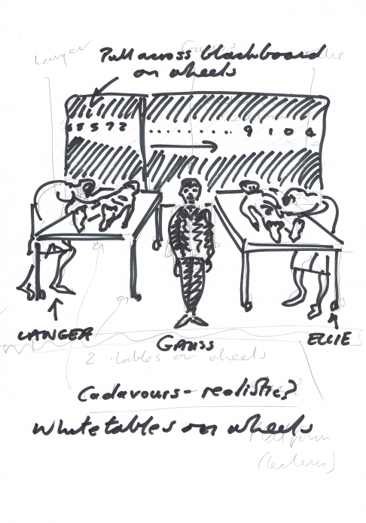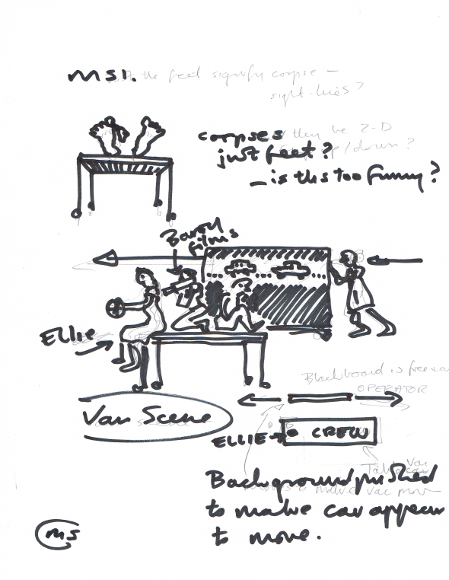

As it happens the blackboard idea was rejected merely on practical grounds of cost and availability. Ironically the entire back wall of the lecture theatre at Princeton consisted of moveable blackboards, revealed at the flick of a switch. However we did not know that until the day we arrived, by which time an alternative had been found. Not only do mathematicians use blackboards to demonstrate their thinking, they also use simple pen and paper of course. Plain white paper became the ‘appropriate’ material for the set. Appropriate in that, in itself, it is a symbol of thinking and calculation, and appropriate because its use, in various manifestations, allowed us to create the visual parallels to the text and, crucially, to serve the narrative. Form and function. There are so many, often conflicting, agendas when designing for any performance: the search for form and function in physical objects, shapes, colours and textures, the need to tell the story, the practical and economic parameters which are unique to each production, aesthetic harmony and style etc., etc. This is partly why I draw so much. These are fleeting thoughts. ‘What ifs?’ If it cannot be that then it can be something else. All a designer can do is hang on to the core of what they want to achieve, knowing that it can be achieved in thousands, or millions of ways. How they achieve it, is unknown during the design process, which makes these drawings, in effect, research.
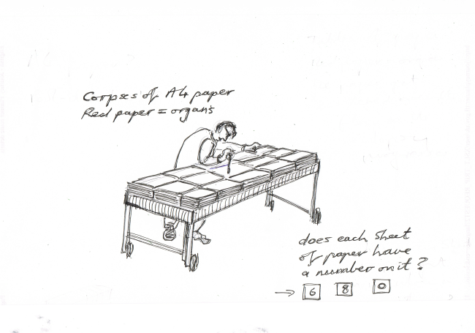
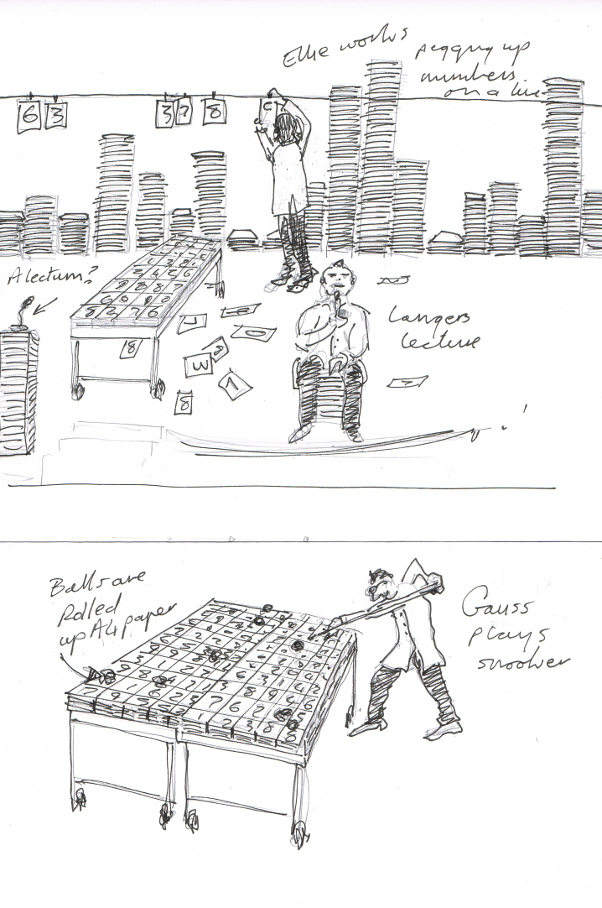
Following these initial drawings a lot of emails/scanned drawings fly across the Atlantic over the next three months. I propose the main material for the design to be sheets of A4 paper – reams and reams of them - some with numbers on. Stacks of paper become the corpses, the snooker table, the towering landscape of the city – the fabric of the world of the play. Then fate steps in. Princeton has a new policy, trying to cut down on the use of paper and my design proposal effectively wastes a lot. Sustainability, quite rightly, is yet another agenda when making performance. So, as often happens, despite the apparent simplicity of Plan A, it’s Plan C or even D that ends up on stage. As ever, I’m left wondering if maybe Plan D wasn’t actually better than Plan A after all…For example, the paper corpses on the rolling tables were not only very clear in what they signified, but they helped make sense of the text, as numbers could be literally extracted from the two bodies. This idea would not have emerged, had the original blackboard idea been funded.

What happened when you switched to a new venue?

The variations to the design are largely due to the different venues as each performance is facilitated by its ‘siting’. The lecture hall at Princeton was a pretty standard wood panelled shell with a shallow apron stage and small wings space. The wings facilitated some tension wires that span the entire width on which the white paper (down to a few hundred sheets now) could be pegged to create numbers/sequences/functions etc. These wires also gave us a way of finding a visual parallel to a scene where an apparently random sequences of numbers were likened to the ebb and flow of cars on a freeway.

At Berkeley there was no wing space and so no tension wires, but this time we were aware of rolling blackboards as a backdrop to the performance. Instead of pinning up numbers and drawings on a line, we either stuck them on the blackboard, or removed paper to reveal, pre-chalked on the boards, what at Princeton had been pinned up. This was complex to work out and I did a series of more technical sketches to show how this could work.
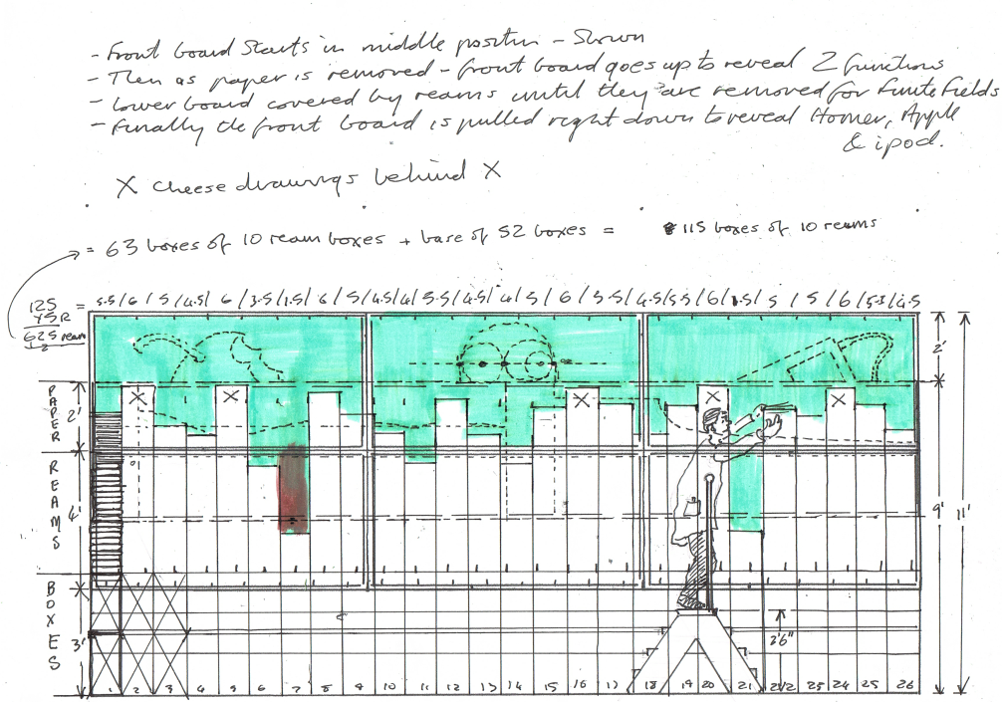

As there were no lines at Berkeley we had to find another way to show the ‘freeway’ scene, this time reverting to an earlier idea of using the rolling tables as cars, relative to each other. In terms of staging potential, Berkeley offered less, but I felt the design worked better at Berkeley because it got closer to the spirit of the text – it was purer, more about the text and less about the design for its own sake.

The photos here are from the productions at Princeton and Berkeley and demonstrate the different approach dictated by the differences in venue.

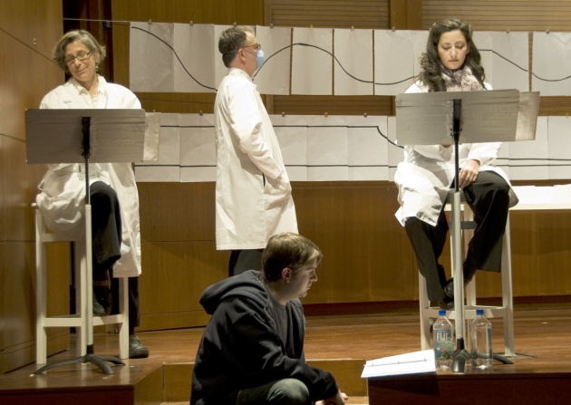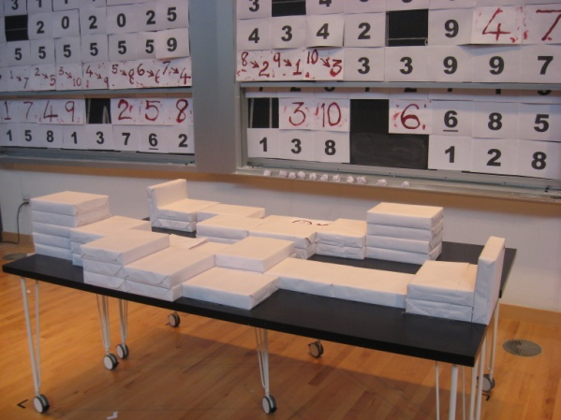

Princeton Berkeley

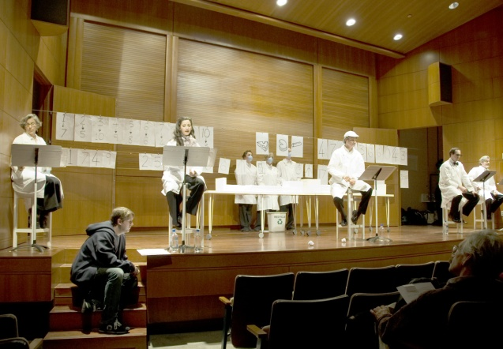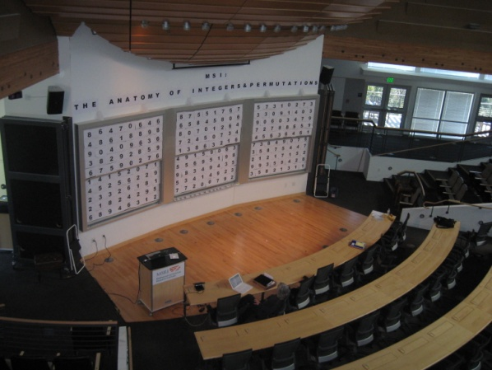

Do you think you succeeded?

These are complex retrospective conclusions to describe and words seem inadequate for the task. There is a tendency, when writing articles like this, to present work that comes across as a complete success in terms of dramaturgy, scenography, design aesthetic etc. The truth is that success was a bit ‘hit and miss’. Like most designs I’ve completed, some things worked whilst others did not. Some of the visual ideas read clearly whilst others got confused. Sometimes the performance told the story of the text at the same time as it disseminated complex mathematical theories whilst being visually stimulating. At other times it achieved one of those at the expense of the other, and then the result was less satisfying. However, at least it was engaging. The remarkable thing about the experience for me was not so much my work in creating the visual performance, but in the response from the audience of mathematicians to that work, and in particular, to the creative processes involved.

What did you learn from the experience?

I have talked to quite a few mathematicians during this experience and all were interested in my process, ie how a designer generated visual ideas from text to ‘stage’. This is partly the purpose of my section in this chapter and is of course, a big question that I’ve struggled to answer for many years. My own approach as a mixture of pragmatics dictated by the space and text, aesthetics, and tapping into that intangible sense of what I hoped would make interesting theatre. Inevitably the creative process starts simply with looking: at the world around you – at objects, people, places, the way things move, shape, colour, texture, etc. …and then, it’s all about finding connections. Here I found common ground with mathematics. The process begins with observations of the world around you – numbers, sequences, patterns, shapes, rhythms…and then, it’s all about finding connections. In both cases, I feel it’s about looking hard enough to discover what is actually already there. The recently departed American Choreographer, Merce Cunningham, defined an artist as someone who just looked more closely at things around them than other people did. This is clearly also true of mathematicians.

I learnt a lot from this curious theatre hybrid that I helped to initiate, designed, and to which I contributed performance. The fact that I did all that, having been educated as a Theatre Designer, is proof of the range of skills which experience in the discipline encourages and develops. I have now experienced the pressure of putting up an eight digit prime number, live on stage, digit by digit, knowing that if I got the order wrong, the whole audience would forget the story, and think ‘that’s not a prime’. Most people would never know…these people would have. Mostly I remember the generosity of all those I’ve met on this project, in embracing a new idea: applying theatre and performance techniques to disseminate and perhaps even celebrate, abstract mathematical ideas.

Maybe there is a future in drawing computers.

Postscript:

Since writing this article we have completed a third performance of the text at yet another venue: A conference room at the Queen Elizabeth Hotel in Montreal Canada, as part of a Canadian Math Conference (Dec 2012).

This venue was not a lecture theatre, but simply a large carpeted room used for dinners, large meetings and presentations. It had some rostra available, usually placed at one end with a lectern on them and with chairs placed in rows in front. When I received the ground plan via email, I noticed it was virtually a square. This led me to dispense with the ‘end on’ configuration and instead opt for what in theatre is called traverse staging. For traverse, the seats are placed in rows facing each other with a middle aisle used as the ‘stage’ – a kind of corridor.

For this performance of MSI, I kept the rostra at one end of this corridor, on which I placed the actors. Jenny and I (the ‘Operators’) were in the corridor itself. Therefore the audience watched the operators (and each other watching them) in the context of the ‘voice-over’ from the actors, who they could turn to see if they wished. This separation, I felt, was clearer than seeing the actors read, and the operators perform, together. The operators’ ‘action’ was always meant as a counterpoint, not merely an accompaniment, to the spoken text. In this way, I felt it was the best of the three designs, created more through serendipity and sensitivity to physical space, than any great revelation on my part.

One other significant factor changed at Montreal, this time as a result of reflection on the previous two manifestations of the design. I had always felt the shape of the text to go from sudden chaos to a restored order, as the revelation of how the numbers interconnect, becomes evident as the text unfolds. This journey was explicitly visualized at Montreal, by showing the ‘murder’ of the two Math elements (integers and permutations) before the text began – a kind of pre-show, or dumb-show in Shakespeare’s theatre: demonstrating the issue about to be played out and resolved. This is another element which made the Montreal presentation, in my view, the most successful - because the visual element ran in parallel with the shape of the text, its underlying structure and form made manifest in the visual.

